**36.How to replace Nan values by using forward and backward methods in python?**

**Objective:**

* To replace the missing values by using forward and backward methods using python.

**Process:**

* Import pandas library.
* Read the sample data set.
* Find the missing values in the data set.
* Replace the missing values by using pad() and bfill().

**Input:**

* Data set(csv file).

**Output:**

* Completed data set without missing values.

**Source code:**

#import libraries

import pandas as pd

#Read the sample data

data=pd.read_csv('/home/soft27/soft27/Sathish/

Pythonfiles/Houseprice.csv')

#create data frame

df=pd.DataFrame(data)

print(df)

#Find the missing values

print("Find missing values")

print(df.isnull())

#Replace the missing values(Nan) using forward

print("Replace the Nan values")

print(df.fillna(method='pad'))

#Replace the missing values(Nan) using backward

print(df.fillna(method='bfill'))

**Screen shot:**

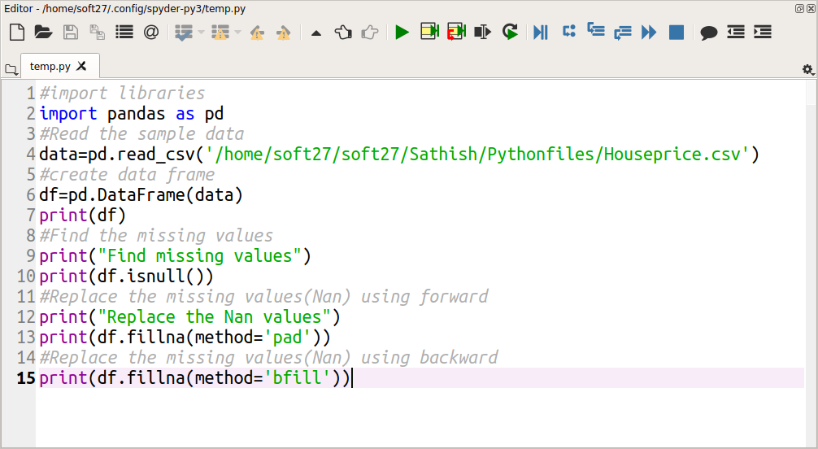

**Output:**

